Biol 4513/5513 - Population Ecology

Lab 1 – CMR (Capture-Mark-Recapture)

1/21/15

**Familiarize yourself with the data:**

Open the data file (snake CMR.xlsx) and look over the snake capture data in the “RAW DATA” tabs. Familiarize yourself with the data columns and format.

* How many samples (days) are there in each year?
* How many total captures are there? How many individuals?
* Make a bar graph that compares total captures and total individuals in the two years.

Now look at the “MATRIX-NOSEX” tab. This is the data arranged in the form of an encounter matrix, which is how it is input into program MARK.

* How does the arrangement of these data differ from the RAW data file?
* How would you convert the raw data into an encounter matrix like this?

**Getting started in MARK:**

Open program MARK. Go to File>New to start a new project. Under ‘Select Data Type’ Select the option ‘Closed Captures’ and then ‘Full Likelihood p and c’. Take a second to look over all of the different options here to get an idea of how many different things you can do in MARK.

Enter a filename, and browse to “2015nosex.inp” for your input file

Enter the appropriate number of sampling occasions (days)

For now we just have one group (later we will have 2, males and females)

Click OK – you are ready to start running models….

**Constructing Models:**

We will construct models using the PIM chart – under the PIM menu. Open this and explore a little, what do you think this is showing us?

Use space below to take notes on using the PIM chart:

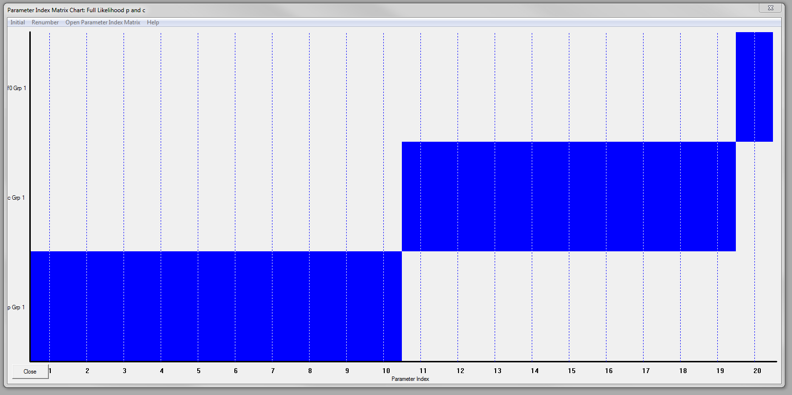

Once you are familiar with using the PIM chart, run models that represent different combinations of behavioral responses and time-varying p and c.

Use space below to make comments on interpreting model rankings.

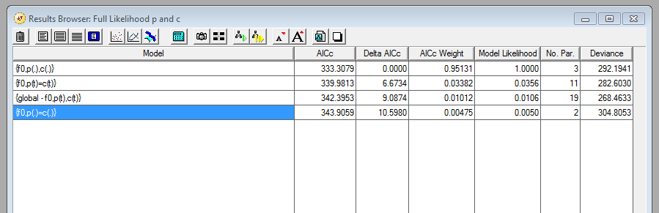

What do these rankings tell us about variation in detectability in this system?

Use the options for ‘view real parameters’ and ‘view derived parameters’ to compare outputs of the various models.

* Do all of the outputs make sense?
* What can parameter estimates for p and c tell us about why the models ranked the way they did?
* What is the estimated population size (n-hat)? How confident are we in that number? What sources of variation in detection might be leading to imprecision in that estimate?

**Incorporating group (sex) differences**

Now lets try accounting for another source of variation – sex differences. The excel file contains another encounter matrix that has sex groupings. To use this matrix, copy the encounter histories column, paste into MS Notepad, and save the file as ‘2005sex.inp’. Be sure the file extension is .inp not .txt .

Now you can start a new analysis in MARK that includes 2 groups, females and males. You will notice that the PIM chart now has the potential to separate all parameters among the sexes. Start by keeping the sexes grouped and running the same set of models you ran previously. Then run each of the models with the sexes differing.

Examine the model rankings and parameter estimates for selected models.

* What can this tell us about differences in behavior among the sexes?
* How do they contribute to our attempt to estimate population size?
* How would this change your sampling design if you did the study again?

**Comparing years**

Ok, now we can finally think about comparing years.

The major challenge for you here is that I haven’t created an encounter matrix for 2014. Take a creating an encounter matrix that can be pasted into an .inp file as we did above. After you’ve struggled with this some, I’ll show you some tricks.

Run the same set of analyses on the 2014 data.

How are the years similar and different?

Do the results of CMR agree with the relative abundance graphs you made from the initial capture counts?